**Buat DFA yang dapat menerima bahasa berikut dengan 4 buah state :**

1. L(A) = {x | x = anb nc n , n≥ 1,x ∈ {a,b,c} }
2. Gambar Transisi

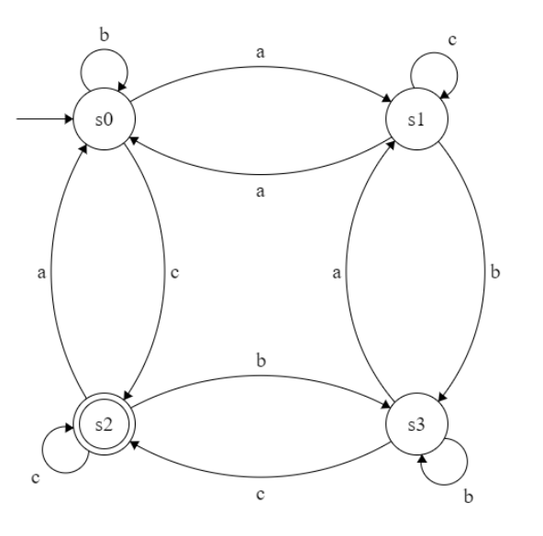

1. Fungsi Transisi

|  |  |  |  |  |  |  |
| --- | --- | --- | --- | --- | --- | --- |
| T = (s0, a) = s1 |  | T = (s1, a) = s0 |  | T = (s2, a) = s0 |  | T = (s3, a) = s1 |
| T = (s0, b) = s0 |  | T = (s1, b) = s3 |  | T = (s2, b) = s3 |  | T = (s3, b) = s3 |
| T = (s0, c) = s2 |  | T = (s1, c) = s1 |  | T = (s2, c) = s2 |  | T = (s3, c) = s2 |

1. Tabel Transisi

|  |  |  |  |
| --- | --- | --- | --- |
| **T** | **a** | **b** | **c** |
| s0 | s1 | s0 | s2 |
| s1 | s0 | s3 | s1 |
| s2 | s0 | s3 | s2 |
| s3 | s1 | s3 | s2 |

1. L(A) = {x | x = (ab)mCn , m,n n≥ 1, x ∈ {a,b,c} }
2. Gambar Transisi

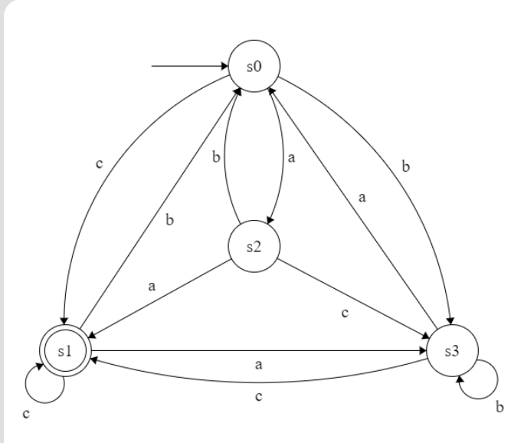

1. Fungsi Transisi

|  |  |  |  |  |  |  |
| --- | --- | --- | --- | --- | --- | --- |
| T = (s0, a) = s2 |  | T = (s1, a) = s3 |  | T = (s2, a) = s1 |  | T = (s3, a) = s0 |
| T = (s0, b) = s3 |  | T = (s1, b) = s0 |  | T = (s2, b) = s0 |  | T = (s3, b) = s3 |
| T = (s0, c) = s1 |  | T = (s1, c) = s1 |  | T = (s2, c) = s3 |  | T = (s3, c) = s1 |

1. Tabel Transisi

|  |  |  |  |
| --- | --- | --- | --- |
| **T** | **a** | **b** | **c** |
| s0 | s2 | s3 | s1 |
| s1 | s3 | s0 | s1 |
| s2 | s1 | s0 | s3 |
| s3 | s0 | s3 | s1 |

1. L(A) = {x | x = (ab)* c, x ∈ {a,b,c} }
2. Gambar Transisi

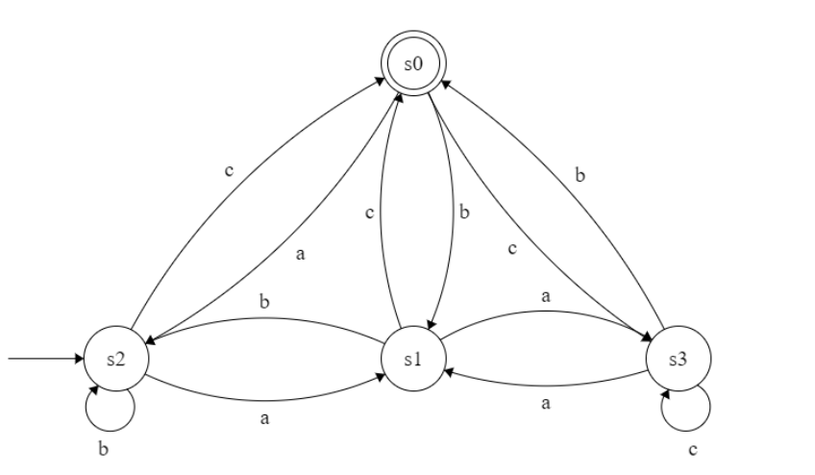

1. Fungsi Transisi

|  |  |  |  |  |  |  |
| --- | --- | --- | --- | --- | --- | --- |
| T = (s0, a) = s2 |  | T = (s1, a) = s3 |  | T = (s2, a) = s1 |  | T = (s3, a) = s1 |
| T = (s0, b) = s1 |  | T = (s1, b) = s2 |  | T = (s2, b) = s2 |  | T = (s3, b) = s0 |
| T = (s0, c) = s3 |  | T = (s1, c) = s0 |  | T = (s2, c) = s0 |  | T = (s3, c) = s3 |

1. Tabel Transisi

|  |  |  |  |
| --- | --- | --- | --- |
| **T** | **a** | **b** | **c** |
| s0 | s2 | s1 | s3 |
| s1 | s3 | s2 | s0 |
| s2 | s1 | s2 | s0 |
| s3 | s1 | s0 | s3 |